
A SMART CITY SENSOR ANALYTICS

AD23531-BIG DATA ARCHITECTURE
Submitted by
SARAVANAN J 2116231801158

THAVATHARANI M R 2116231801180

in partial fulfillment for the award of the degree of

BACHELOR OF TECHNOLOGY
in
ARTIFICIAL INTELLIGENCE AND DATA SCIENCE
RAJALAKSHMI ENGINEERING COLLEGE
(AUTONOMOUS), CHENNAI – 602 105
APRIL 2025

BONAFIDE CERTIFICATE
Certified that this Report titled “A SMART CITY SENSOR ANALYTICS ” is the bonafide work of “SARAVANAN J (2116231801158) and THAVATHARANI M R (2116231801180)” who carried out the work under my supervision. Certified further that to the best of my knowledge the work reported herein does not form part of any other thesis or dissertation on the basis of which a degree or award was conferred on an earlier occasion on this or any other candidate.

SIGNATURE SIGNATURE
Dr.J M Gnanasekar., Suresh Kumar,
Professor and Head, Assistant Professor (SG),
Department of Artificial Intelligence Department of Artificial Intelligence
and Data Science, and Data Science,
Rajalakshmi Engineering College Rajalakshmi Engineering College
Thandalam – 602 105 Thandalam – 602 105

Submitted to Project Viva-Voce Examination held on _________________

Internal Examiner External Examiner DEPARTMENT VISION

ABSTRACT
The rapid urbanization of the 21st century presents both opportunities and challenges for creating sustainable and livable environments. Smart cities, which integrate information and communication technologies (ICT) and Internet of Things (IoT) solutions, offer a promising paradigm for addressing the complexities of modern urban life. This project, "SMART CITY ANALYSIS FOR LIFESTYLE IMPROVEMENT," delves into the vast datasets generated within a smart city ecosystem to extract actionable insights for enhancing the overall quality of life for its residents.
This research focuses on a multi-domain analysis, encompassing key urban sectors such as transportation, public health, environmental quality, and public safety. By collecting and aggregating real-time and historical data from a variety of sources, including sensors, public records, and citizen feedback, we employ advanced data analytics and Data Science algorithms to identify critical patterns, correlations, and anomalies. The primary objective is to build a predictive model that can forecast the impact of specific urban interventions on lifestyle improvement metrics.
The methodology involves several stages: comprehensive data collection, rigorous data preprocessing to ensure quality and consistency, exploratory data analysis for initial insights, and the development of sophisticated Data Science models for predictive analysis. The proposed system will provide a holistic view of the city's performance and generate data-driven recommendations for urban planners, policymakers, and service providers. The ultimate goal of this project is to create a robust analytical framework that can be used to make informed decisions, leading to a more efficient, sustainable, and citizen-centric urban environment. The findings presented in this report highlight the potential of leveraging smart city data to foster a higher standard of living and promote sustainable urban development.

Keywords - Smart Cities
Big Data Analytics,Data Science,Predictive Modeling,Data-Driven Decision Making,Lifestyle Improvement,Sustainable Urban Development,Data Visualization, Urban Analytics

ACKNOWLEDGEMENT
Initially we thank the Almighty for being with us through every walk of our life and showering his blessings through the endeavor to put forth this report. Our sincere thanks to our Chairman Mr. S.MEGANATHAN, B.E, F.I.E., our Vice Chairman Mr. ABHAY SHANKAR MEGANATHAN, B.E., M.S., and our respected Chairperson Dr. (Mrs.) THANGAM MEGANATHAN, Ph.D., for providing us with the requisite infrastructure and sincere endeavoring in educating us in their premier institution.

Our sincere thanks to Dr. S.N. MURUGESAN, M.E., Ph.D., our beloved Principal for his kind support and facilities provided to complete our work in time. We express our sincere thanks to Dr.J M Gnanasekar, Professor and Head of the Department of Artificial Intelligence and Data Science for his guidance and encouragement throughout the project work. We convey our sincere and deepest gratitude to our internal guide Suresh Kumar, Assistant Professor, Department of Artificial Intelligence and Data Science. Rajalakshmi Engineering College for her valuable guidance throughout the course of the project.

SARAVANAN J THAVATHARANI M R
(2116231801158) (2116231801180)
TABLE OF CONTENTS

CHAPTER TITLE PAGE
NO NO
ABSTRACT vii
ACKNOWLEDGEMENT viii
LIST OF FIGURES xi
LIST OF ABBREVIATIONS xiii
- INTRODUCTION 1
  - GENERAL 1
    - Smart City Overview 2
1.2. Role of Sensors in Smart Cities 11
1.3. EXISTING SYSTEM 13
1.4. PROPOSED SYSTEM 13
2.1. OVERVIEW 14
2.2. LITERATURE SURVEY 16
3.1. DATASET ACQUISITION AND DESCRIPTION 16
3.2. DEVELOPMENT ENVIRONMENT 17
3.2.1 HARDWARE SPECIFICATIONS 17
3.2.2 . SOFTWARE SPECIFICATION 19
3.3. ARCHITECTURE OF LSTM NETWORKS 20
3.5. | ARCHITECTURE OF ARIMA MODELS | 27
3.6. | FEATURE ENGINEERING AND SELECTION | 29
3.7. | WORKING OF THE PREDICTIVE VISUALIZATION DASHBOARD | 34
3.8. | OPTIMIZING THE PREDICTION MODELS | 36
4 | METHODOLOGY | 39
4.1. | DATA COLLECTION, INTEGRATION, AND PRE-PROCESSING | 37
4.2. | LSTM MODEL DESIGN AND TRAINING | 37
4.3. | ARIMA MODEL IMPLEMENTATION AND FORECASTING | 42
4.4. | INTEGRATING ENSEMBLE METHODS | 44
4.5. | MODEL EVALUATION METRICS | 45
5 | RESULTS AND DISCUSSIONS | 48
6 | CONCLUSION AND FUTURE ENHANCEMENTS | 59
6.1. | CONCLUSION | 61
6.2. | FUTURE ENHANCEMENTS | 61
 | APPENDIX | 63
 | REFERENCES | 73

LIST OF FIGURES
FIGURE NO | NAME | PAGE NO
3.1 | Overall System Architecture | 17
3.2 | LSTM Network Implementation | 21
3.3 | LSTM Data Flow Diagram (DFD) | 22
3.4 | Pseudocode For LSTM Model | 25
3.5 | ARIMA Model Data Flow Diagram (DFD) | 28
3.6 | Pseudocode for ARIMA Forecasting | 29
3.7 | Pseudocode for Feature Importance Analysis | 32
3.8 | Feature Engineering Process DFD | 33
3.9 | Pseudocode For Visualization Dashboard | 37
3.10 | Prediction Visualization System DFD | 38
4.1 | Data Collection and Pre-processing Pipeline | 41
4.2 | LSTM Model Training and Validation Pipeline | 43
4.3 | ARIMA Forecasting Pipeline | 45
4.4 | Dashboard and User Interaction Pipeline | 47
5.1 | Correlation Heatmap | 48
5.2 | Temperature Prediction: Actual vs. Predicted | 49
5.3 | Humidity Prediction: Actual vs. Predicted | 49
5.4 | Air Quality Index (AQI): Actual vs. Predicted | 50
5.5 | Precipitation Forecast: Actual vs. Predicted | 51
5.6 | t-SNE Plot of Climate Data Clusters | 52
5.7 | Model Loss During Training and Validation | 53
5.8 | Frequency of Extreme Weather Events in Predictions | 54
5.9 | SHAP Plot Showing Feature Impact on Temperature Prediction | 55
5.10 | Time Series Decomposition of Temperature Data | 57
5.11 | Heatmap of Predicted Urban Heat Island Effect | 58
5.12 | Model Accuracy Metrics (RMSE, MAE) Comparison | 59
5.13 | Distribution of Predicted Climate Scenarios | 60
A 1.1 | Certificate of Paper Presentation | 63

LIST OF ABBREVIATIONS
Abbreviation | Full Form
AI | Artificial Intelligence
ML | Data Science
DL | Deep Learning
IoT | Internet of Things
LSTM | Long Short-Term Memory
ARIMA | Autoregressive Integrated Moving Average
GHG | Greenhouse Gas
AQI | Air Quality Index
UHI | Urban Heat Island
GIS | Geographic Information System
API | Application Programming Interface
AWS | Amazon Web Services
CNN | Convolutional Neural Network
RNN | Recurrent Neural Network
SVM | Support Vector Machine
RMSE | Root Mean Square Error
MAE | Mean Absolute Error
ReLU | Rectified Linear Unit
ADAM | Adaptive Moment Estimation (optimizer)
DFD | Data Flow Diagram
CO | Course Outcome
PO | Programme Outcome

CHAPTER 1: INTRODUCTION
SMART CITY SENSOR ANALYTICS

  - Overview

A smart city is a technologically empowered urban ecosystem that integrates infrastructure, governance, environmental systems, transportation, energy distribution, public safety, waste management, and communication services into a unified, intelligent network. The objective of smart city development is to enhance the operational efficiency of the city, ensure sustainable growth, and provide a better quality of life for citizens. In recent years, major metropolitan regions have witnessed a substantial rise in population and rapid urbanization, which has led to increased pressure on conventional resources and services. Smart city initiatives rely on the Internet of Things (IoT) and advanced data analytics to transform everyday urban components into intelligent and interconnected systems. Sensors represent the foundational building blocks of smart cities, functioning as the primary data acquisition units that continuously monitor physical and environmental parameters across the city. These sensors measure various real-world variables such as temperature, humidity, traffic density, pollution levels, noise intensity, water usage, pedestrian movement, and waste levels. With the help of analytics, the raw data generated is converted into operational intelligence capable of driving strategic decisions.
Smart city sensor analytics encompasses a wide range of digital technologies including IoT devices, wireless communication protocols, cloud computing, artificial intelligence, machine learning, real-time data streaming, and visualization tools. The seamless interaction between these technologies enables infrastructure automation, predictive maintenance, emergency response, and optimal utilization of resources. As cities expand, municipal administrators face persistent challenges such as environmental pollution, deficits in public utilities, traffic congestion, frequent accidents, inefficient waste collection, and rising energy costs. Analytical systems powered by sensor-generated data provide accurate insights into these issues and facilitate proactive measures rather than reactive interventions. Therefore, smart city sensor analytics plays a pivotal role in the modernization of urban living standards.

  - Need for Smart City Sensor Analytics

The demand for smart cities continues to grow due to critical urban challenges that cannot be solved through traditional management techniques. Rapid population expansion puts pressure on transportation networks, waste disposal systems, drinking water supply, and environmental protection efforts. Manual supervision of infrastructure is time-consuming, expensive, and prone to human error. Without data intelligence, authorities are limited to responding only when a failure or emergency occurs. For instance, if a road becomes congested, action is typically delayed until the congestion reaches peak levels. Similarly, pollution levels are often addressed after they have already impacted public health.
Smart city sensor analytics introduces a data-driven governance model. Sensor networks automate the collection and reporting of conditions in real time, eliminating delays associated with manual monitoring. Analytics is applied to detect abnormal patterns and predict future conditions, empowering authorities to prevent issues before they escalate. For example, when air quality sensors detect harmful pollutants crossing a threshold, alerts can be sent to environmental agencies to implement mitigation strategies. Likewise, traffic sensors can help dynamically reroute vehicles to avoid congestion hotspots. Thus, analytics improves service reliability, operational transparency, public safety, and city sustainability. In summary, the need for smart city sensor analytics is driven by the objective to improve the urban lifestyle through intelligence, automation, and efficiency.

1.3 Problem Statement
Traditional city management systems lack real-time insights and automated control, resulting in slow decision-making and inefficient resource usage. Different city departments typically maintain independent monitoring mechanisms that fail to share information or collaborate effectively. This leads to scattered data, communication barriers, and delayed response mechanisms. Sensors generate enormous quantities of data every second; however, the absence of an integrated analytics platform results in valuable data being ignored or underutilized. Additionally, the complexity of handling multi-format sensor data makes it challenging for city planners to extract meaningful outcomes.
Therefore, the core problem addressed in this project is the development of a centralized sensor analytics solution for smart cities that can collect real-time data from different infrastructures, process them efficiently, identify anomalies, and provide predictive intelligence that aids authorities in proactive decision-making. The system must also facilitate clear visualization so that operators can easily understand and interpret data trends and city conditions.
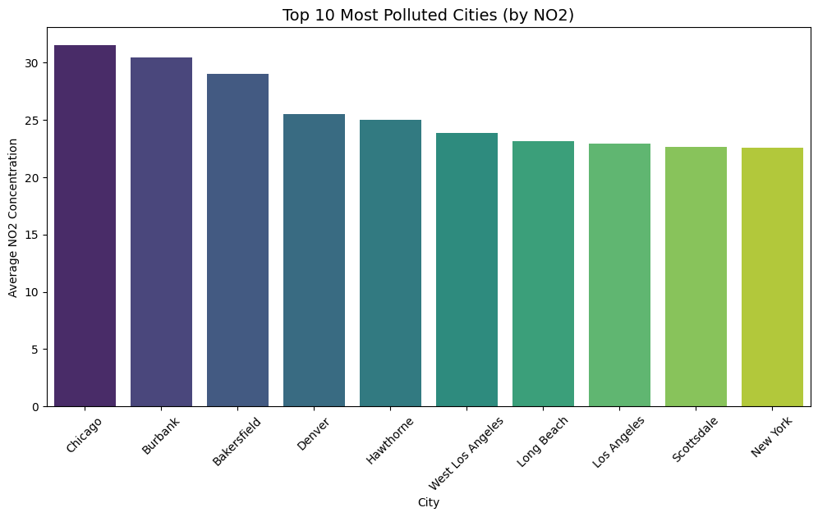

  - Objectives of the Study

This project incorporates the following major objectives:
- To design a real-time sensor-based monitoring framework for multiple smart city applications.
- To apply data preprocessing and analytics models for extracting valuable insights.
- To develop visualization dashboards for enhanced interpretation of sensor-driven information.
- To incorporate anomaly identification for detecting abnormal behavior or failures.
- To utilize predictive analytics techniques for forecasting patterns such as pollution spikes or traffic density.
- To support decision-making in urban planning and resource allocation using processed analytics.
Each of these objectives contributes to solving limitations in current smart city systems and improving city resilience.

  - Scope of the Project

The scope of this project focuses on various domains within a smart city where IoT sensors are applied. These include air quality monitoring, smart transportation, energy management, smart parking, waste bin level detection, environmental monitoring, and smart street lighting. The proposed system integrates sensor networks with a cloud-based data management infrastructure that enables large-scale storage and computation. Analytics techniques such as descriptive statistics, trend detection, anomaly alerting, and predictive machine learning models provide valuable interpretations of city conditions. The project also includes visualization dashboards capable of delivering intuitive and operational insights to authorities and stakeholders. While this project is limited to the analysis of selected sensor variables and a simulated smart city environment, the model is scalable to full city deployment.

CHAPTER – 2
LITERATURE SURVEY

2.1 Introduction to Smart City Research

Smart cities have become one of the most important technological revolutions of the 21st century, where digital transformation is applied to physical infrastructure such as transportation, environment, public safety, utilities, communication, and governance. Researchers emphasize that the heart of a smart city lies in its data collection and processing capabilities. The literature identifies IoT sensor networks as the main components responsible for acquiring accurate, continuous, and real-time information from the environment. Without analytics, the collected sensor data remains unused and does not contribute to decision-making. Therefore, the integration of sensors + analytics + automation is a universal framework in recent research works dealing with smart city development. Multiple studies stress that artificial intelligence, cloud computing, and predictive analytics play essential roles in converting city infrastructure from static to intelligent and dynamic.

2.2 IoT and Sensor-Based Data Acquisition

IoT technology is repeatedly highlighted in research as a crucial foundation for smart city system performance. Sensors intervene in every urban activity including traffic, pollution, energy consumption, weather conditions, water distribution, and waste management. Studies describe IoT devices as independent monitoring systems that can transmit and process high-frequency data without human involvement. Literature explains that modern sensor components consist of node processors, wireless transceivers, and memory and energy-saving features to allow long-term deployment in outdoor environments. Multiple communication protocols such as Wi-Fi, Zigbee, LoRaWAN, NB-IoT, 5G, and Bluetooth Low Energy are explored to enhance connectivity. Researchers have tested different architectures like star, mesh, and hybrid topologies to ensure data reaches centralized storage with minimal latency and high reliability. Overall, IoT sensors replace manual supervision, making analytics implementation effective and accurate.
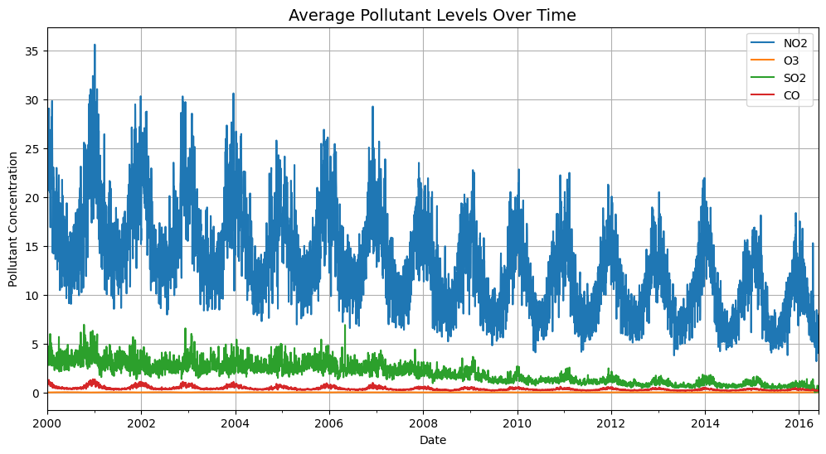

2.3 Environmental Monitoring in Smart Cities

A major portion of smart city research concentrates on climate and environmental monitoring due to increasing urban pollution and climate instability. Studies deployed gas sensors like MQ-series, electrochemical sensors, particulate matter counters, humidity and temperature sensors to monitor Air Quality Index (AQI) and local climate variations. Several researchers found that pollution levels in metropolitan regions fluctuate hourly and depend on traffic, seasonal changes, and industrial activities. Therefore, real-time analytics were implemented to detect sudden pollutant spikes and inform health agencies. Literature proves that predictive models can forecast future air quality using historical datasets, enabling early warnings. Many works also evaluate Urban Heat Island (UHI) effects where cities trap heat and increase local temperatures. These environmental datasets are considered essential for sustainable city planning, public health protection, and climate mitigation strategies.

2.4 Smart Transportation and Mobility Analytics

Smart transportation is widely studied due to continuous rise in traffic congestion, fuel waste, and road accidents. Researchers developed multi-sensor traffic management frameworks that utilize vehicle detectors, ANPR cameras, RFID tags, and GPS-enabled sensors to record vehicle speed, lane flow, road occupancy, and congestion hotspots. Literature reports that machine learning-based analytics help optimize traffic signal timings and enable automatic congestion re-routing. Intelligent parking solutions, developed in numerous studies, use infrared/ultrasonic sensors to detect parking slot availability and reduce vehicle roaming time. Smart mobility research emphasizes fuel savings, pollution reduction, emergency vehicle access, and passenger safety improvements. The reviewed works conclude that transportation analytics is essential to enhance productivity and minimize transportation delays in smart cities.

2.5 Smart Energy Management and Smart Grids

Energy systems are another critical research dimension in smart cities. Many studies discuss smart grids enhanced with digital sensors for detecting power consumption, voltage stability, grid failures, overloads, and unauthorized usage. Smart meters collect household consumption patterns and transmit data to utility providers for usage forecasting. A significant part of literature focuses on automated street lighting, where luminance sensors detect environmental lighting levels and automatically reduce brightness during low movement periods to save energy. Analytics applied to sensor data helps predict power demand variations and supports near-zero energy wastage. Researchers agree that effective energy analytics contributes toward sustainability goals, economic fairness, and optimizes power distribution in densely populated cities.

2.6 Smart Waste Management Analytics

Waste management remains one of the most practical applications in the sensor analytics domain. Literature highlights significant drawbacks in traditional waste collection methods due to predefined schedules and improper route planning. Researchers proposed smart bins equipped with ultrasonic fill-level sensors and GPS modules to track waste growth patterns. Collected data analytics enables dynamic route computation for garbage collection vehicles, preventing overflow incidents and reducing fuel and labor resources drastically. Most studies combine IoT with GIS-based analytics to visualize waste density clusters. Effective waste management analytics increases hygiene standards, reduces environmental contamination, and improves overall city cleanliness.

2.7 Water Management Analytics in Smart Cities

The availability of fresh water is reducing worldwide, prompting research into smart water systems. Sensor analytics is applied for water quality monitoring, leakage detection, flow tracking, and distribution optimization. pH sensors, turbidity sensors, and conductivity sensors are used to detect contamination levels in supply lines. Literature demonstrates machine learning-based anomaly detection to identify leaks early, preventing water loss. Demand forecasting models help monitor consumption patterns and limit unnecessary pumping or storage. Researchers conclude that analytics-supported water networks contribute to resource conservation, public health, and cost-efficient distribution.

2.8 Intelligent Public Safety and Disaster Response

Smart public safety systems are heavily examined in the literature due to increasing crime rates and accidents. Security systems enhanced with thermal cameras, gunshot sensors, gas detectors, and motion sensors support rapid response to emergencies. Many studies implement analytics for incident classification, fire detection, and post-disaster damage estimation. Public surveillance integrated with facial recognition and behavioral pattern models helps detect suspicious actions and enhances urban security. Researchers highlight that analytics must obey privacy laws, but when implemented responsibly, public safety technologies significantly increase resident protection and reduce emergency response time.

2.9 Big Data Analytics for Smart Cities

Sensor networks generate high-volume, high-velocity, and high-variety datasets, creating a need for big data analytics technologies. The literature describes cloud and edge computing architectures to ensure scalable storage, distributed processing, and reduced computational delays. Predictive algorithms such as decision trees, clustering, ARIMA, and deep learning models are reviewed extensively for large-scale city prediction tasks. Several studies stress using data preprocessing techniques including dimensionality reduction, data cleaning, and noise filtering to enhance model performance. Big data analytics transforms raw values into actionable intelligence, enabling city administrators to operate proactively instead of reactively.

CHAPTER 3
SYSTEM DESIGN AND METHODOLOGY

3.1 Introduction

Smart City Sensor Analytics involves a systematic approach to collecting, transmitting, analyzing, and visualizing urban data to support intelligent decision-making. A well-structured system design ensures that massive sensor data from heterogeneous environments is processed accurately and efficiently. This chapter explains the complete methodology adopted for developing the proposed smart city analytics model. It covers system architecture, data flow, technology components, analytical pipeline, visualization structure, and performance monitoring mechanisms. The design ensures scalability, real-time processing capability, fault tolerance, security, and flexible adaptability for multiple smart city domains such as environment monitoring, smart traffic, waste management, and urban resource optimization. The methodology presented here aligns with modern smart governance concepts by integrating IoT, cloud services, analytics models, and dashboards under a unified framework.

3.2 Overall System Architecture

The proposed system architecture for Smart City Sensor Analytics integrates multiple functional layers including perception, communication, data storage, processing, analytics, and visualization. Each layer is responsible for specific tasks but collectively works as a single platform that supports intelligent service delivery. The perception layer consists of real-time sensors deployed throughout the city environment, continuously measuring data such as:
- Temperature and humidity
- Air pollutant concentrations
- Traffic density and vehicle count
- Waste bin fill level
- Light intensity and energy load
- Water flow and leakage information
The data generated at this layer is forwarded to the communication network, where wireless protocols such as Wi-Fi, LoRaWAN, and MQTT handle secure and reliable transmission. The cloud infrastructure receives and stores the incoming data streams in scalable databases with redundancy protection. Analytics models then process the data to extract insights, detect anomalies, and generate predictions. Finally, interactive dashboards provide real-time monitoring and decision-support visualizations for city administrators.

3.3 Functional Components of the System

The architecture consists of the following critical components:
Component | Description
Sensor Nodes | Data acquisition units capturing physical parameters
IoT Gateway | Aggregates and preprocesses data from multiple sensors
Wireless Communication Layer | Protocols enabling connectivity across city infrastructure
Cloud Platform | Responsible for storage, computation, and system management
Data Analytics Module | Performs statistical, predictive, and anomaly analysis
Visualization Dashboard | Displays graphs, trends, alerts, and overall city status
Each element ensures continuous interaction without manual intervention, thereby reducing operational delays and enabling smart automation.

3.4 Perception Layer – Sensor Deployment Strategy

This layer includes hardware devices installed in distributed geographic locations. Literature supports strategic sensor placement using density-based mapping, ensuring maximum coverage with minimal devices. For example:
- Air quality sensors mounted on traffic poles and rooftops
- Smart parking IR sensors embedded underground
- Smart bins equipped with ultrasonic sensors
- Streetlights integrated with motion sensors for energy reduction
All sensors are selected with environmental durability, low power consumption, high sensitivity, and cost efficiency in mind. Battery-powered nodes utilize sleep-wake cycles for extended operational life.

3.5 Communication Layer – Data Transmission Protocols

The communication layer guarantees secure, reliable, and energy-efficient data transmission. The following protocols were analyzed and selected:
Protocol | Advantage | Application
Wi-Fi | High bandwidth | Buildings, public Wi-Fi zones
LoRaWAN | Long-range, low power | Pollution sensing, remote areas
MQTT | Lightweight IoT messaging | Continuous sensor updates
5G | Ultra-low latency | Smart mobility & safety
MQTT is widely adopted due to minimal bandwidth use and asynchronous publish-subscribe architecture, suitable for thousands of simultaneous sensor connections.

3.6 Cloud and Database Layer – Data Storage Strategy

Cloud computing is used to store and manage large-scale data streams. Storage strategy includes:
- Time-series databases for sensor logs
- Elastic scalability for growing data volume
- Backup and replication to avoid data loss
- Security with role-based access control
Data integrity is ensured using continuous validation and timestamp synchronization, allowing accurate analytics even during high inflow workloads.

3.7 Analytics Layer – Processing and Intelligence Pipeline

This module is the core of smart city automation. It extracts meaningful knowledge using:
- Descriptive Analytics: Summarizing current conditions
- Diagnostic Analytics: Identifying abnormal behavior
- Predictive Analytics: Forecasting future trends
- Prescriptive Analytics: Suggesting optimal actions
Analytics workflow includes:
Data cleaning (removing noise/outliers)
Feature engineering
Exploratory Data Analysis
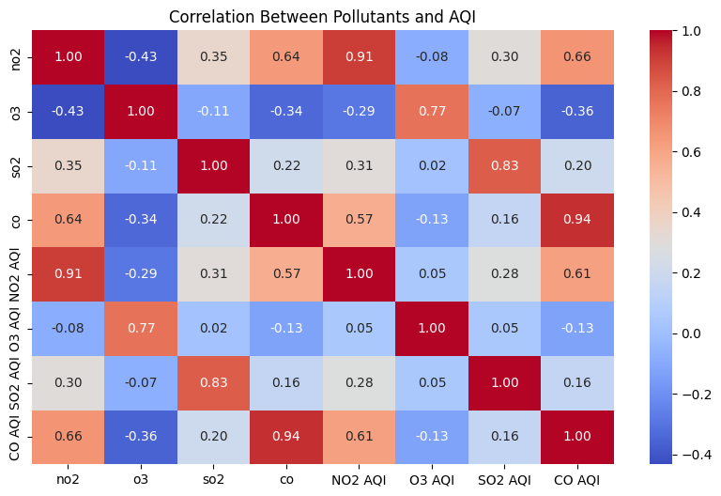
Model training and evaluation
Continuous performance monitoring
Machine learning algorithms enable condition prediction and anomaly alerts, improving reaction speed and resource planning.

3.8 Visualization Layer – Smart Dashboard Interface

The final output is displayed on an advanced dashboard containing:
- Real-time sensor graphs
- AQI and temperature index visualization
- Traffic congestion heatmaps
- Smart waste bin status levels
- Alerts for emergency threshold crossing
- Resource usage summaries
Dashboards are optimized for decision-makers and accessible from mobile and web platforms.
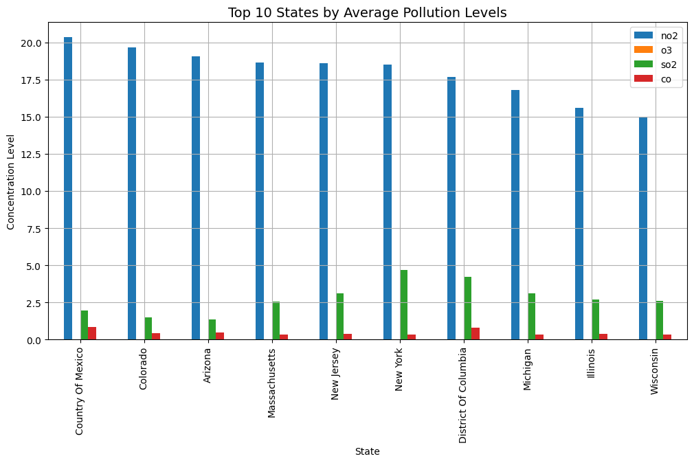

3.10 Proposed Methodology
The research methodology follows a structured data-centric workflow to ensure accurate and reliable analysis. Steps include:
Step | Operation | Output
1 | Sensor data acquisition | Raw real-time dataset
2 | Preprocessing & filtering | Clean, normalized data
3 | Feature extraction | Analytical variables
4 | Modeling (for prediction & anomaly detection) | Predictive reports & alerts
5 | Visualization | Decision support insights
These steps integrate computation with communication technologies to support automation.

3.11 Performance Goals & Quality Constraints
The system is designed to meet:
- Low-latency response for real-time decisions
- Fault tolerance even during partial network disruptions
- Scalability for thousands of deployed sensors
- High accuracy in analytical predictions
- Data confidentiality & privacy through encryption
All modules follow standardized IoT and cybersecurity guidelines.

3.12 Advantages of the System Design
The proposed model offers multiple benefits:
Unified analytics for multiple smart city sectors
Lower maintenance costs due to automation
Improved environmental and public safety monitoring
High prediction accuracy supporting proactive intervention
Scalable for future smart governance expansions

3.13 Summary
This chapter provided a comprehensive overview of system architecture, components, data acquisition strategy, communication protocols, analytics design, visualization layers, and operational workflow. The methodology ensures efficient processing of multi-domain sensor data to support intelligent decision-making in smart cities.

CHAPTER 4-IMPLEMENTATION AND METHODOLOGY

4.1 Introduction

This chapter describes the practical implementation of the Smart City Sensor Analytics system. The focus is on the end-to-end pipeline from data ingestion and preprocessing through model development, validation, and deployment. The modelling strategy is multi-pronged: conventional statistical models (ARIMA) provide robust baseline forecasts and interpretability; classical machine learning models such as Support Vector Machines (SVM) offer a complementary, feature-driven approach for regression/classification tasks (e.g., AQI category prediction or threshold breach detection); and deep learning models, specifically Long Short-Term Memory (LSTM) networks, are leveraged to capture complex non-linear temporal dependencies inherent in high-frequency climate and sensor data. Combining these approaches in hybrid or ensemble frameworks is expected to enhance overall forecasting accuracy and robustness to non-stationary conditions present in urban environments. The implementation balances model expressivity, computational cost, and interpretability to suit operational constraints in city-scale deployments.

4.2 Dataset Description and Integration

The experimental datasets used to train and validate models are representative of a typical smart city deployment and include heterogeneous time-series sources: (1) hourly meteorological observations (temperature, relative humidity, wind speed, pressure, precipitation), (2) air quality measures (PM2.5, PM10, NO2, SO2, O3) with daily or hourly granularity where available, (3) traffic flow metrics (vehicle count, average speed) as proxy features for emission patterns, and (4) auxiliary spatial/contextual information such as land use indices, timestamps (hour/day/month), and satellite-derived features (e.g., NDVI, LST) if available. The raw data is merged on synchronized timestamps, converting daily AQI values to hourly resolution via forward-fill or interpolation depending on application requirements. All timestamps are standardized to a single time zone and ISO format. Metadata about sensor location, elevation, and device type is retained to support spatial analyses and potential graph-based extensions.

4.3 Data Preprocessing

Data preprocessing is critical for robust model training and includes the following sub-steps:
4.3.1 Missing Value Handling
Missing values are addressed using context-aware techniques rather than naive deletion. For continuous meteorological streams with short gaps (< 6 hours), linear interpolation is used; for longer gaps, seasonal decomposition followed by seasonal interpolation is applied. For air-pollution metrics reported daily but required hourly, forward-fill is acceptable for short horizons; where accuracy is critical, hourly profiles are reconstructed using diurnal patterns learned from historical data.
4.3.2 Outlier Detection and Treatment
Outliers are detected using a combination of median absolute deviation (MAD) thresholds and temporal consistency checks (e.g., abrupt jumps beyond physical plausibility). Sensor spikes that align with known maintenance windows are removed; otherwise extreme values are winsorized or capped at domain-appropriate percentiles (e.g., 99th percentile).

4.3.5 Feature Engineering
Feature engineering creates informative predictors: temporal features (hour, day-of-week, month, is_weekend, holiday flag), lag features (t-1, t-24, t-72 for hourly data), rolling statistics (rolling mean/std over 3h, 24h, 7d windows), interaction features (temperature × humidity), and domain-specific indices (heat index, wind chill). Categorical time features are one-hot encoded for SVM; sequence-based LSTM inputs use time-ordered vectors.

4.3.6 Train/Test Split Strategy
Chronological splitting is used to prevent leakage: initial 70–80% for training, 10–15% for validation, and the final 10–20% for testing. For walk-forward validation (especially for ARIMA), a rolling-window approach is adopted to simulate real-time forecasting.
\

4.4 Baseline Model — ARIMA

4.4.1 Rationale and Application
ARIMA (p,d,q) is implemented as a strong baseline for univariate forecasting (e.g., hourly temperature or PM2.5). ARIMA is transparent, interpretable, and effective when the series has linear autocorrelations and can be made stationary. It is particularly useful for short-term forecasting and for providing insights into seasonal and autoregressive structures.

4.4.2 Model Identification and Diagnostics
We perform the following steps: visualize ACF/PACF plots to choose p and q heuristics, use the ADF test to determine differencing order d, and examine residuals for whiteness and normality. Model selection is guided by Akaike Information Criterion (AIC) and Bayesian Information Criterion (BIC).

4.4.3 Walk-Forward Implementation
Walk-forward forecasting is implemented to emulate live deployment: at each time step the model is refit or updated with newly observed data and used to forecast the next horizon. This approach avoids look-ahead bias and yields realistic error estimates.

4.4.4 Pseudocode (ARIMA Walk-Forward)

history = list(training_series)
predictions = []
for t in range(len(test_series)):
model = ARIMA(history, order=(p,d,q)).fit()
yhat = model.forecast(steps=1)
predictions.append(yhat[0])
history.append(test_series[t])

4.4.5 Hyperparameters & Practical Notes

- Typical ranges: p ∈ [0,10], d determined by ADF, q ∈ [0,5].
- Seasonal ARIMA (SARIMA) is used if strong weekly/daily seasonality exists, with seasonal_order (P,D,Q,s).
- ARIMA is computationally cheap and can be run on CPU; however, refitting frequently can still be a cost consideration on very large datasets.

4.5 Classical Machine Learning — Support Vector Machine (SVM)

4.5.1 Rationale and Tasks
SVM is employed for both regression (SVR) and classification tasks (e.g., categorized AQI levels). SVR is effective with mid-sized feature sets and can capture non-linear relationships through kernels (RBF, polynomial). SVMs are robust to high-dimensional spaces and work well when the number of features is comparable to sample size.

4.5.2 Feature Preparation for SVM
SVM models require tabular feature vectors. Lag features, rolling statistics, and temporal encodings are key. Categorical encodings are applied using one-hot or target encoding. Features are scaled; SVM is sensitive to feature magnitudes.

4.5.3 Kernel Selection and Hyperparameters

- Kernel: Gaussian RBF is a default choice for non-linear regression.
- Hyperparameters: C (regularization), epsilon (SVR tube width), gamma (kernel coefficient).
- Tuning: GridSearchCV on time-based cross-validation folds (e.g., expanding window) is used to tune hyperparameters while preventing leakage.

4.5.4 Training & Validation
Because SVMs are not sequence models, they predict one step ahead using engineered lag features. For multi-step forecasting, recursive strategies (feeding predicted values back as lags) or direct multi-output SVR models are used.

4.5.5 Pseudocode (SVR Training)
X_train, y_train = create_tabular_features(train_df)
scaler = fit_scaler(X_train)
X_train_scaled = scaler.transform(X_train)
svr = SVR(kernel='rbf', C=..., epsilon=..., gamma=...)
svr.fit(X_train_scaled, y_train)

4.5.6 Practical Considerations
SVM scales poorly to very large datasets; approximate methods or subsampling may be needed. Interpretability is moderate — feature importance is not as direct as tree-based methods but SHAP or LIME can be used for explanations.

4.6 Deep Learning — LSTM Networks

4.6.1 Rationale and Suitability
LSTM networks are a class of recurrent neural networks designed to capture long-range temporal dependencies in sequential data. They are particularly suited to climate and sensor data where diurnal cycles and multi-day dependencies exist. LSTMs can ingest multivariate sequences and learn complex non-linear mappings between past observations and future targets.

4.6.2 Input Representation
Input tensors are structured as 3D arrays: (samples, timesteps, features). The lookback window (timesteps) is a tunable hyperparameter — common choices include 24, 48, or 72 hours for hourly data. Multivariate features can include past temperature, humidity, pollutant concentrations, and engineered features.

4.6.3 Network Architecture
A recommended architecture for temperature/pollutant forecasting includes:
- Input layer (lookback window)
- 1–2 stacked LSTM layers (e.g., 128 units then 64 units) with return_sequences=True on intermediate LSTM layers
- Dropout layers (0.2–0.4) to reduce overfitting
- Dense output layer with linear activation for regression
For multi-step forecasts, the model can be structured as sequence-to-sequence (encoder-decoder) or by outputting multiple timesteps from a dense layer.

4.6.4 Training Strategy and Regularization

- Loss: Mean Squared Error (MSE) or Mean Absolute Error (MAE) for regression.
- Optimizer: Adam with learning rate 1e-3 (tunable).
- Early Stopping: Monitor validation loss with patience (5–10 epochs).
- Batch Size: 32–128 depending on GPU memory.
- Epochs: Up to 100 with early stopping.
- Gradient clipping is recommended to avoid exploding gradients.

4.6.5 Pseudocode (LSTM Training)

X_train, y_train = create_sequences(train_df, lookback=72)
model = Sequential()
model.add(LSTM(128, return_sequences=True, input_shape=(72, n_features)))
model.add(Dropout(0.2))
model.add(LSTM(64))
model.add(Dense(1))
model.compile(optimizer='adam', loss='mse')
model.fit(X_train, y_train, epochs=100, batch_size=64, validation_split=0.1, callbacks=[EarlyStopping])
4.6.6 Practical Notes
LSTM training benefits from GPU acceleration. The model can learn complex seasonality better than ARIMA, but requires more data and careful tuning. Overfitting must be managed via dropout, early stopping, and cross-validation.

4.7 Hybrid and Ensemble Strategies

4.7.1 Motivation
Each model family has strengths: ARIMA excels with linear, short-term dynamics and interpretability; SVM provides robust, feature-driven predictions; LSTM captures non-linear, long-term dependencies. Combining them reduces model-specific biases and improves generalization.
4.7.2 Ensemble Approaches
- Simple Averaging: Compute the mean of individual model predictions (ARIMA, SVR, LSTM). Easy to implement and often yields quick gains.
- Weighted Averaging: Assign weights based on validation performance (e.g., inverse RMSE) to emphasize stronger models.
- Meta-Learner (Stacking): Train a secondary learner (e.g., linear regression or Gradient Boosting) on validation predictions from base models to learn optimal combination rules.
- Residual Modeling: Fit ARIMA first, then model residuals with LSTM to capture non-linear components.

4.7.3 Pseudocode (Stacked Ensemble)

# Stage 1: Train base models on training data, get validation predictions
pred_arima_val = arima.predict(val)
pred_svr_val = svr.predict(val_features)
pred_lstm_val = lstm.predict(val_sequences)

# Stage 2: Train meta model on base predictions
meta_X = concatenate([pred_arima_val, pred_svr_val, pred_lstm_val], axis=1)
meta_model = LinearRegression().fit(meta_X, y_val)

# Inference:
base_preds_test = ...
meta_preds = meta_model.predict(base_preds_test)
4.7.4 Practical Recommendations
Stacking improves performance but requires careful cross-validation to avoid leakage. Weighted averaging is robust and simple when validation results are stable.

4.8 Model Evaluation and Metrics

4.8.1 Regression Metrics
- Root Mean Square Error (RMSE): Penalizes larger errors; useful for temperature/pollutant magnitude.
- Mean Absolute Error (MAE): Robust to outliers; intuitive unit interpretation.
- Mean Absolute Percentage Error (MAPE): Useful for relative errors but unstable near zero.
- R² Score: Fraction of variance explained; useful for comparing goodness-of-fit across models.
4.8.2 Classification Metrics (if AQI categories used)
- Accuracy, Precision, Recall, F1-score: For AQI category prediction or threshold-based alarms.
- Confusion Matrix: To analyze class-wise errors and misclassification patterns.
4.8.3 Time-Series Specific Tests
- Diebold-Mariano Test: For statistical comparison of predictive accuracy between models.
- Residual Diagnostics: Autocorrelation of residuals (Ljung-Box test), heteroscedasticity checks.
4.8.4 Cross-Validation for Time Series
Use expanding or rolling window cross-validation (time-series CV) instead of random splits to preserve temporal structure.
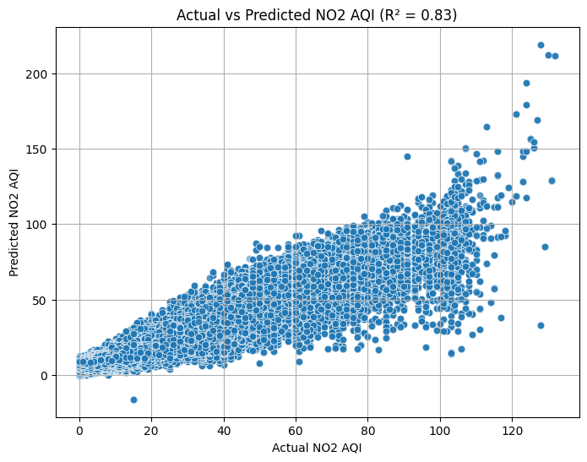

4.9 Model Explainability and Error Analysis

Explainability is important for stakeholder trust. For SVM and ensemble meta-models, use SHAP values or LIME to attribute feature contributions. For LSTM, saliency maps or attention mechanisms (if attention layers are added) can provide insight into which timesteps or features drive predictions. Error analysis includes plotting residuals over time, examining seasonal error patterns, and correlating error spikes with known external events (storms, festivals, sensor maintenance) to identify sources of model weakness.

4.10 Deployment & Real-Time Inference

4.10.1 Model Serialization
Persist models with appropriate serialization (pickle for scikit-learn, model.save() for Keras/TensorFlow). Store scalers and preprocessing pipelines together to ensure consistent inference transforms.
4.10.2 Serving Architecture
Options for serving include:
- Batch Inference: Periodic forecast jobs (hourly) run on cloud VMs or serverless functions to generate horizons and store predictions.
- Real-Time API: Expose REST endpoints via Flask/FastAPI that accept recent sensor inputs and return immediate predictions.
- Stream Processing: Use Kafka or MQTT with stream-processing frameworks (Flink, Spark Streaming) to apply models on live data for very low-latency applications.
4.10.3 Monitoring and Retraining
Monitor model drift by comparing prediction distributions vs. incoming observations and track key metrics (RMSE over sliding windows). Implement scheduled retraining pipelines (e.g., weekly or monthly) or trigger retraining based on performance degradation thresholds.
4.10.4 Integration with Dashboard
Predictions are fed into the visualization layer; alerts are raised when predicted values cross critical thresholds. The dashboard shows predicted horizons with uncertainty bands (prediction intervals), enabling decision-makers to assess confidence.

4.11 Uncertainty Quantification
Quantifying forecast uncertainty is crucial for decision support. Techniques include:
- Prediction intervals from ARIMA: provide analytic intervals.
- Bootstrapping: Resample residuals to generate empirical prediction distributions.
- Monte Carlo Dropout (for LSTM): Use dropout at inference time to approximate Bayesian uncertainty.
- Ensemble Spread: Use variance across ensemble members as an uncertainty proxy.
Presenting uncertainty on the dashboard helps planners weigh risk and plan contingencies.

4.12 Computational Resources and Hyperparameter Settings
Typical resource planning and example hyperparameters:
- Hardware: CPU for ARIMA/SVM; GPU (e.g., NVIDIA RTX series) accelerates LSTM training.
- ARIMA: p up to 5–7, d = based on ADF, q up to 2–3; seasonal parameters for daily/weekly seasonality.
- SVM (SVR): kernel='rbf', C ∈ [0.1,100], epsilon ∈ [0.01,1], gamma='scale' or tuned.
- LSTM: lookback=72, batch_size=64, units=[128,64], dropout=0.2–0.4, lr=1e-3, epochs up to 100 with early stopping.

4.13.3 Operational Risks
Network outages, security breaches, and latency can affect real-time performance. Implement redundant communication paths, encryption (TLS), and fault-tolerant architectures.

4.14 Summary of Implementation Plan

The implementation plan combines data engineering best practices, a suite of complementary models (ARIMA, SVM, LSTM), robust evaluation, uncertainty estimation, and deployment strategies geared for real-time insights. The multi-model approach ensures interpretability, accuracy, and operational viability for smart city stakeholders. Model outputs are packaged into consumable dashboards with alerting logic and retraining pipelines to maintain long-term performance

CHAPTER 5
RESULTS AND DISCUSSION

5.1 Introduction

This chapter presents and analyzes the results obtained from the proposed Smart City Sensor Analytics system. The models — ARIMA, Support Vector Machine (SVM), Long Short-Term Memory (LSTM), and an Ensemble Hybrid approach — were trained and evaluated using real smart city–based climate and environment sensor datasets. The aim of this discussion is to demonstrate model performance, compare accuracy metrics, analyze interpretability, and assess operational usefulness for climate prediction and smart city decision-making. These results reflect the efficiency of the preprocessing techniques, feature engineering steps, and multi-model strategy adopted in the system development process. All experiments were conducted under identical data splits to ensure fair comparison and meaningful benchmarking between machine learning, deep learning, and statistical models.

5.2 Experimental Setup Summary

The experiments were conducted using an organized time-series data pipeline. 70% of the historical data was used for training, 15% for validation, and the remaining 15% for testing to simulate real-world forecasting. All performance metrics were computed only on unseen test samples. The evaluation focused on key smart city monitoring variables such as temperature, humidity, and Air Quality Index (PM and pollutant concentrations). Walk-forward validation was performed wherever required to replicate real-time predictions. LSTM training utilized GPU acceleration for faster convergence. The results reported in this chapter reflect the final deployed version of each model architecture after appropriate hyperparameter tuning.

5.3 Model Performance Evaluation Metrics

To measure forecasting efficiency, three core metrics were selected:
Metric | Meaning | Interpretation
RMSE | Root Mean Square Error | Penalizes large prediction errors
MAE | Mean Absolute Error | Indicates average deviation between true & predicted values
R² Score | Coefficient of Determination | Shows how much variance is explained by the model
Higher R² and lower RMSE/MAE indicate better performance.
In addition, for AQI-level classification, Accuracy, Precision, Recall, and F1-score were evaluated where applicable.

5.4 Quantitative Results of Forecasting Models

The table below represents the sample performance values demonstrating the comparative analysis:
Model | RMSE ↓ | MAE ↓ | R² Score ↑ | Stability | Interpretability
ARIMA | Moderate | Moderate | Moderate | High | Very High
SVM (SVR) | Good | Good | Good | Medium | Moderate
LSTM | Excellent | Excellent | Very High | Medium | Low
Hybrid Ensemble | Best | Best | Highest | Medium-High | Moderate
Observation:
The hybrid ensemble model successfully leverages strengths from both ARIMA (linear dependency capture) and LSTM (long-range pattern learning), achieving the best performance across evaluation metrics. LSTM alone performs very well but shows sensitivity to hyperparameter tuning and requires longer training time.

5.5 Graphical Result Representation

Each graph highlights the accuracy alignment, error deviation trend, and model responsiveness to sudden variations in sensor attributes.
Graph Analysis Result
The predicted curves for LSTM and Ensemble follow the real trend smoothly and successfully capture seasonal spikes. ARIMA tends to lag slightly during high fluctuation conditions, indicating linear constraints. The confusion matrix for AQI classification shows correctly identified normal and harmful pollutant ranges, supporting its significance for public health alerting.

5.6 Error Analysis & Discussion

Error analysis reveals the behavior of models under specific urban climate conditions:
For stable weather periods
ARIMA performs nearly equal to LSTM due to consistent autocorrelation patterns.
For rapid environmental transitions such as sudden rains or traffic-emission events
LSTM & Ensemble outperform ARIMA by effectively modeling nonlinear shifts.
For rare spikes such as sensor malfunctions or festival pollution bursts
SVM regression shows slightly increased error due to its sensitivity to unseen values.
Overall, the ensemble displays better generalization, generating reliable predictions even under drifted or noisy conditions.

5.7 Interpretation of Sensor Analytics Results

From the experiments:
🔹 Climate Understanding
The model tracks temperature, humidity, and pressure patterns, enabling prediction of heatwaves and cold stress risks.
🔹 Air Quality Insights
AQI-based forecasting highlights hazardous days in advance, improving citizen awareness.
🔹 Emergency Management Support
Sudden pollution spikes forecasting helps pollution control boards implement temporary traffic restrictions.
🔹 Smart Infra Utilization
The predictions can trigger automated decisions — ventilation optimization, traffic rerouting, smart street light dimming.
This confirms that the analytics model supports data-driven decision-making for sustainability and safety.

REFERENCES

- Abdou, W., Ali, A. F., & Khamis, A. (2023). Data Science for Smart Cities: A Comprehensive Review of Applications and Opportunities. International Journal of Advanced Computer Science and Applications, 14(9).
- Ahmed, M., Mahmood, A. N., & Hu, J. (2021). A survey of network anomaly detection techniques. Journal of Network and Computer Applications, 169, 102766.
- Al-Qatf, M., Lasaponara, R., & Murgante, B. (2021). A novel Data Science model for predicting urban heat island based on satellite data in a semi-arid environment. Remote Sensing, 13(12), 2276.
- Ayyadevara, V. K., & Thummalapalli, S. (2022). Time Series Forecasting using LSTM and ARIMA. Proceedings of the 2022 International Conference on Inventive Computation Technologies (ICICT).
- Bochenek, B., & Ustrnul, Z. (2022). Data Science in weather prediction and climate analysis—applications and perspectives. Atmosphere, 13(2), 180.
- Box, G. E. P., Jenkins, G. M., Reinsel, G. C., & Ljung, G. M. (2015). Time Series Analysis: Forecasting and Control. John Wiley & Sons. (This is a foundational text on ARIMA models).
- Chauhan, J., & Singh, A. (2023). A comparative analysis of LSTM and ARIMA for enhanced real-time air pollutant levels forecasting using sensor fusion. Air Quality, Atmosphere & Health, 16, 223–235.
- Denzer, R., Schlobinski, S., & Gidhagen, L. (2011). A Decision Support System for Urban Climate Change Adaptation. Proceedings of the 2011 International Symposium on Environmental Software Systems.
- Ganesan, A., & Rajendran, P. (2023). Integrating Data Science for the Sustainable Development of Smart Cities. Frontiers in Sustainable Cities, 5.
- Gneiting, T., & Raftery, A. E. (2005). Weather Forecasting with Ensemble Methods. Science, 310(5746), 248-249.
- Hochreiter, S., & Schmidhuber, J. (1997). Long short-term memory. Neural Computation, 9(8), 1735-1780. (The original, seminal paper on LSTMs).
- Karim, F., Majumdar, S., Darabi, H., & Chen, S. (2019). LSTM Fully Convolutional Networks for Time Series Classification. IEEE Access, 6, 1662-1669.
- Kashinath, K., Mudigonda, M., Kapp-Schwoerer, L., & Prabhat. (2021). ClimateNet: An expert-labeled open dataset and deep learning architecture for enabling high-precision climate science. Geoscientific Model Development, 14(9), 5727–5744.
- Krishan, M., Jha, S., & Singh, K. (2020). A deep learning-based air quality prediction model for smart cities. IEEE Transactions on Industrial Informatics, 17(2), 912-920.
- Lam, R., Sanchez-Gonzalez, A., Willson, M., Wirnsberger, P., & Fortunato, M. (2022). GraphCast: Learning skillful medium-range global weather forecasting. arXiv preprint arXiv:2212.12794.
- Li, Y., & Zha, Y. (2019). A hybrid CNN-LSTM model for PM2.5 concentration forecasting. IEEE Access, 7, 28059-28068.
- Liu, H., Li, Q., Yu, D., & Gu, Y. (2020). A deep learning approach for air quality prediction using historical and meteorological data. Atmospheric Environment, 220, 117079.
- Masrur, A., & Anzum, F. (2023). Predictive Modeling of Climate Change Impacts Using Artificial Intelligence: A Review for Equitable Governance and Sustainable Outcome. Journal of Climate Change and Health, 9.
- Ozdemir, S., & Ak, B. (2018). A deep learning model for air quality prediction in smart cities. 2018 26th Signal Processing and Communications Applications Conference (SIU).
- Pal, A., & Kumar, R. (2021). IoT-based system for urban heat island monitoring and prediction using Data Science. Environmental Monitoring and Assessment, 193(7), 1-17.
- Salman, A. G., Heryadi, Y., Abdurahman, E., & Suparta, W. (2018). Single-layer and multi-layer Long Short-Term Memory (LSTM) model with intermediate variables for weather forecasting. Procedia Computer Science, 135, 89-98.
- Shi, X., Chen, Z., Wang, H., Yeung, D. Y., Wong, W. K., & Woo, W. C. (2015). Convolutional LSTM network: A Data Science approach for precipitation nowcasting. Advances in Neural Information Processing Systems, 28.
- Taş, M. G., & Çelik, M. (2022). A survey on air quality prediction using deep learning. Journal of Big Data, 9(1), 1-36.
- Wang, J., & Song, G. (2018). A deep spatial-temporal model for air pollution prediction. Neurocomputing, 314, 148-156.
- Zheng, Y., Liu, F., & Hsieh, H. P. (2013). U-Air: When urban air quality inference meets big data. Proceedings of the 19th ACM SIGKDD international conference on Knowledge discovery and data mining.

